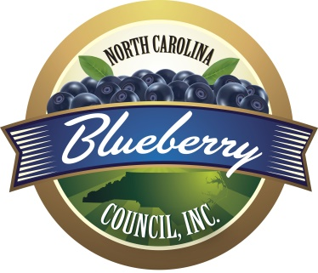

Call for Nominations for the Board of Directors

NCBC is pleased to announce the call for nominations for two at-large positions on the Board of Directors. The two positions open are due to the expiration of the three-year terms for Willie Moore and George Mote, Jr. The term for these positions will be three years, beginning in January 2026 and ending January 2029.

Directors currently serving are (denotes term ending):
Willie Moore, President / Sec.-Treas. (Jan. 2026) Ivanhoe Blueberry Farms
Sam Rose, Vice President (Jan. 2028) Legacy Blueberry Farms
Brandon Norris (Jan. 2028) SonRise Farms
George Mote, Jr. (Jan. 2026) Mote Plantation Farms
Joey Benton (Jan. 2027) Bettin On Blues Farm
Matthew Moore (January 2027) Ivanhoe Farms
Ralph Carter Jr., Honorary Lifetime Carter Farms
Service on the NCBC Board of Directors promotes personal and professional growth, skill development and unique experience. It also provides an opportunity to drive the decisions of our organization.

Directors are instrumental in assisting the Council in achieving our strategic plan of being a non-profit corporation created to:
- Promote efficient production, packing, handling, storing, processing, and marketing of blueberries and to secure and distribute to its members information and trends relative to the operation and management of the blueberry business.
- Promote research work for the purpose of discovering and developing better or new varieties, methods of production, packing, handling, storing, processing, marketing, and disease control.
- Promote through advertising, service work, merchandising, tours, and any other means, the enjoyable consumption of North Carolina blueberries.

Board service also provides these unique opportunities:
•Develop valuable skills in non-profit governance, program planning, and strategic planning
•Expand your network of professional contacts
•Gain recognition from your employer, community, or peers

(Continued on Reverse Side)
Qualifications
Candidates should have a demonstrated ability to lead others, a strong interest in all aspects of blueberry growing, processing, and consumption, ability to communicate effectively (in person and/or through writing), and reliability in following through on commitments and meeting deadlines.
Help lead NCBC into the future by nominating a colleague or yourself for the position of Director-At-Large.

The Call for Nominations closes on December 30, 2025 and the selection of the candidate slate will be determined. The election will be held at a Members Only meeting during the Open House in January, 2026 with new Board Members taking office immediately. Voting is restricted to Members in good standing whose membership dues are paid prior to the meeting – one vote per Grower (farm).

Nomination Process
Complete the nomination form to recommend a colleague or yourself for a Director position on the Board by December 30, 2025.

You may nominate as many people as you like. Please submit one nomination form per candidate. We strongly encourage you to discuss your nomination with the candidate prior to submission to determine his or her interest and willingness to serve as a member of the NCBC Board. The Board of Directors will review all nominations received to determine the slate of candidates that will be presented to the membership.

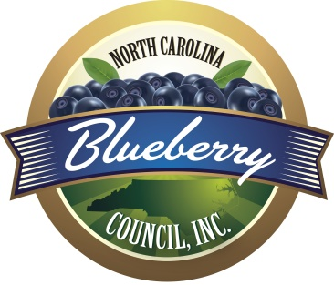

NORTH CAROLINA BLUEBERRY COUNCIL BOARD OF DIRECTORS NOMINATION FORM

Deadline for nominations is December 30, 2025

Candidates Name: ________________________________________________

Company/Employer: __________________________________________________

Address: __________________________________________________________

City: _____________________________________ State _______ Zip __________

Telephone: ______________________ Email: _____________________________

Nominated by: _______________________________________________________
(Self-Nominations are welcomed)

How will the North Carolina Blueberry Council benefit from the nominee’s involvement on the Board? ____________________________________________________________________

____________________________________________________________________

____________________________________________________________________

____________________________________________________________
Return form via US Mail: Electronically:
Brenda Park, Executive Director Email to b.park@ncblueberrycouncil.org
North Carolina Blueberry Council
213 Davidson Road
Greenville, SC 29609

